Did you know?
Forest Hills Gardens has a connection with the writer Harriet Beecher Stowe

Being that it’s still Black History Month, most of us are familiar with the social altering novel “Uncle Tom’s Cabin” by Harriet Beecher Stowe. Her book educated all readers on the harsh conditions experienced by enslaved African Americans back in 1851, before the outbreak of The Civil War.

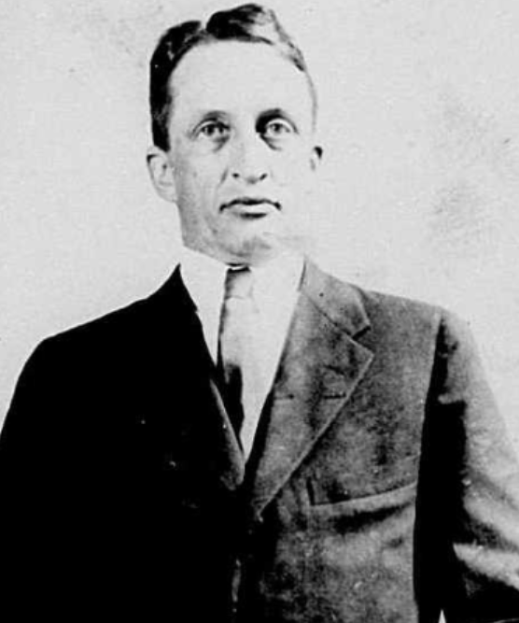 | 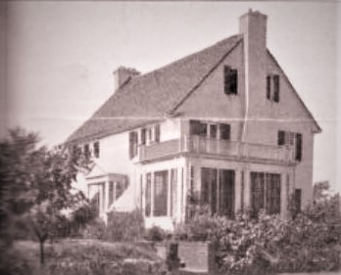
Leyman Beecher Stowe & house at 275 Greeway South

In the 1920’s Leyman Beecher Stowe, Harriet Beecher Stowe’s Grandson, was one of the first Forest Hills Gardens residents. Not only was he very active in the community he also was one of the first presidents of The Gardens Corporation.

